California State University Fullerton

CPSC 462



Object Oriented Software Design

Use Case Model – Annex 2

for the



Hotel Room Reservation

System

Check-in

Fully Dressed Use Case

|  |
| --- |
| **Allen Rivas** |
| Chief Technical Officer (CTO) |
| [allen.rrivas30@csu.fullerton.edu](mailto:allen.rrivas30@csu.fullerton.edu) |

Revision History:

| Version | Date | Summary of Changes | Author |
| --- | --- | --- | --- |
| 1.0 | March 23, 2021 | * First draft. To be refined primary during elaboration phase. | Allen Rivas |
| 1.1 | April 27, 2021 | * Update this draft with a new logo. Updated Main Success and Alternation Path Scenarios. Updated the system sequence diagrams for both Main and Alternative. | Allen Rivas |
| 1.2 | May 16, 2021 | * Updated this draft by adding change bars to indicate the changes that have been made. | Allen Rivas |

Table of Contents

1 Use Case Description 1

1.1 Use Case Title 1

1.2 Scope 1

1.3 Category 1

1.3.1 Risks addressed 1

1.4 Level 1

1.5 Primary Actor(s) 1

1.6 Stakeholders and Interests 1

1.6.1 Director 1

1.6.2 System Administrator 1

1.7 Preconditions (Entrance Criteria) 1

1.8 Success Guarantee (Exit State) 1

1.9 Main Success Scenario 1

1.10 Extensions (Alternate paths) 2

1.11 Special Requirements 2

1.12 Technology and Data Variations List 2

1.13 Frequency of Occurrence 2

1.14 Miscellaneous 2

2 System Sequence Diagrams 3

2.1 Check-in Guest 3

2.1.1 Scenario Description 3

2.1.2 System Sequence Diagram 3

2.2 Check-out Guest 4

2.2.1 Scenario Description 4

2.2.2 System Sequence Diagram 4

# Use Case Description

## Use Case Title

Maintain Guest

## Scope

Hotel Room Reservation System

## Category

Architecturally Significant

### Risks addressed

1. ID: 3 and Low Skill/Knowledge Level Staff

## Level

User goal

## Primary Actor(s)

* Receptionist

## Stakeholders and Interests

### Director

Update and make implementations to the system through the provided system features. Having the capabilities of retrieving information from the system that can be beneficial to the hotel in a business.

### System Administrator

Have scheduled updates that help provided more tools that help other users to customize the hotel room reservation system to their liking.

## Preconditions (Entrance Criteria)

Receptionist is required to have an account created under their personal information, if not then create one.

## Success Guarantee (Exit State)

Guest information is identified. Reserved room is confirmed. Check-in is generated. Check-in in is system is updated. Confirmation is generated.

## Main Success Scenario

1. The receptionist requests to authenticate into the system providing name and password. The system responds with transaction ID.
2. The receptionist request to list the guest’s reservation providing the guest’s name and confirmation number. The system responds with the guest’s reservation information (room type, floor preference, and room number.
3. The receptionist request room assignment providing guest’s name, credit/debit information and room number. The system responds with room number and receipt of payment.
4. The receptionist requests a room key given the guest’s name and room number. The system responds with the specified room key for the given guest.
5. The receptionist requests to terminate session providing transaction ID. The system responds with termination.

## Extensions (Alternate paths)

1. The receptionist decides to check-out guest.
   1. The receptionist requests to authenticate into the system providing name and password. The system responds with transaction ID.
   2. The receptionist request guest’s assigned room, proving guest’s name and room number. The system responds with guest’s room number.
   3. The receptionist requests total bill providing guest’s name and room number. The system responds with bill of total cost (includes amenities and services).
   4. The receptionist requests to pay bill providing guest’s name, room number, and credit/debit information. The system responds with guest’s receipt.
   5. The receptionist requests to terminate session providing transaction ID. The system responds with termination.
2. The receptionist decides to cancel check-in.
   1. The receptionist requests to authenticate into the system providing name and password. The system responds with transaction ID.
   2. The receptionist requests to cancel check-in providing guest’s username. The system responds with check-in cancelation receipt.
   3. The receptionist requests to terminate session providing transaction ID. The system responds with termination.

## Special Requirements

Login authorization response within 15 seconds 95% of the time.

## Technology and Data Variations List

1. Login information entered by keyboard.
2. Guest information entered by.

## Frequency of Occurrence

Frequency of occurrence would be at least 1,000 per day.

## Miscellaneous

Open issues on the system are, what customization is needed for different receptionist? Can the receptionist use the guest’s card information? Can the receptionist use the guest’s information?

# System Sequence Diagrams

## Check-in Guest

### Scenario Description

The receptionist will be check-in the guest using the hotel room reservation system. The receptionist will be required to login. They will also need guest information like, username and password. They will eventually request a receipt as a form of verification that the guest has checked in.

### System Sequence Diagram

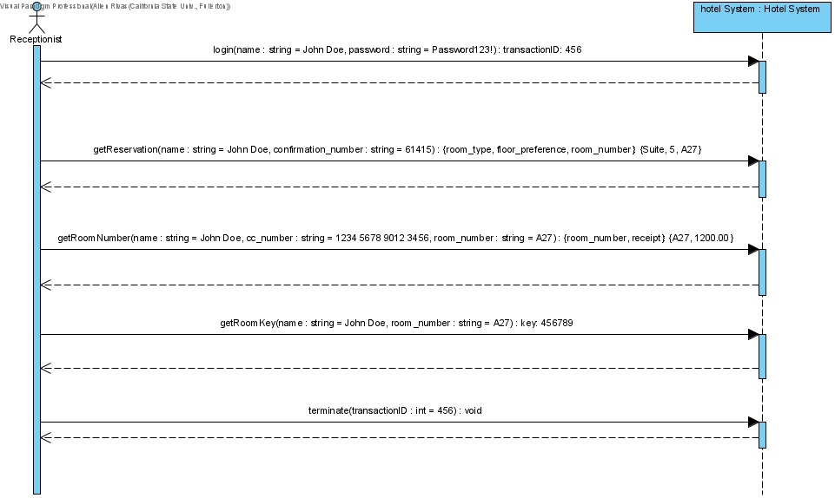

## Check-out Guest

### Scenario Description

The receptionist will be check-out the guest using the hotel room reservation system. The receptionist will be required to login. They will also need guest information like, username and password. They will eventually request a receipt as a form of verification that the guest has checked out.

### System Sequence Diagram

